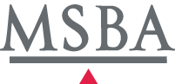
Meeting Agenda

Alternative Legal Models Task Force

Tuesday, June 7, 2016
8:00-10:00 a.m.

Minnesota State Bar Association
3rd Floor, City Center
600 Nicollet Mall
Downtown Minneapolis
Honors Room

Co-Chairs: Ken White and Susan Wiens

AGENDA

- Introductions (5 minutes)

- Reports and preliminary recommendations from subcommittees (1 1/2 hours)
  - Forms
  - Washington Model
  - Business Models

- Next Steps (25 minutes)
  - Drafting responsibilities
  - Preliminary discussion of presentations and listening sessions

If you would like to participate in the meeting via telephone, please dial 877-226-9607 and enter conference code 8732028341# when prompted.

