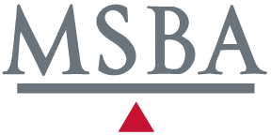

2015 North Star Lawyer
Verification Form

Participation in the North Star Lawyer program is reserved exclusively for members of the Minnesota State Bar Association. For membership information, please contact the MSBA at (800) 882-6722.

Name: MN Atty Reg #:
# Pro Bono Hours Firm Name:
Address:
Phone Number: E-Mail:

I hereby certify that, in 2015, I provided 50 or more hours of legal services at no fee and without expectation of fee
- primarily to persons of limited means; or
- to organizations in matters that are designed primarily to address the needs of persons of limited means; or
- other activities as described in Minnesota Rules of Professional Conduct, Rule 6.1 (b)(1) or (2).

(Signature) (Date)

Please submit this form electronically to Steve Marchese, smarchese@mnbar.org.

Deadline date for 2015 is February 29, 2016.

Please print your name legibly and exactly as you want it to appear in any recognition announcements and advertisements.

